MEMORANDUM

Date: August 22, 2023

To: Save the Sound and Westchester County

From: Biohabitats, Inc.

Subject: Watershed Opportunities Technical Memorandum

Biohabitats conducted field assessments within the Hutchinson River watershed to identify opportunities to improve watershed health. Identification of watershed restoration opportunities were completed through desktop analysis and field assessments in targeted subwatersheds. A prioritization framework was then utilized to identify opportunities to move forward in planning and design. A treatment analysis was conducted to evaluate the pollutant load potential associated with the identified opportunities. This memorandum summarizes the methodology used during the field assessment, prioritization process, and treatment analysis.

Field Assessment
Throughout the week of April 24th, 2023, a two-person team from Biohabitats conducted upland field assessments for the Westchester County portion of the Hutchinson River watershed to identify water quality improvement and habitats enhancement opportunities. Due to the large size of the watershed, field efforts targeted priority subwatersheds identified through the Comparative Subwatershed Analysis and input from Save the Sound, Westchester County, and the Watershed Steering Committee. Three type of assessments were conducted to facilitate a broad range of interventions: Hotspots, Retrofits, and Reforestation.
Hotspot Assessment: targeted locations that may be contributing large amounts of debris, eroding pavement, unruly bulk storage of materials, chemicals, or oil and grease into the watershed. These locations can contribute to the watershed’s pollutants of concern including low dissolved oxygen and the oil and grease.
Retrofit Assessment: targeted large areas of untreated impervious cover and examined opportunities to provide runoff reduction. For retrofit opportunities, climate resiliency considerations included larger stormwater facility footprints and sizing to account for larger storm events. Selected solutions leaned towards cost-effective practices known to be effective at volume management and that include an overflow system (e.g., bioretention areas and submerged gravel wetlands).
Reforestation Assessment: targeted areas with the potential to increase tree canopy cover and remove impervious cover. These sites also had the potential to provide co-benefits such as ecosystem services (i.e., heat island mitigation, habitat corridors), enhance community aesthetics, provide erosion control, and remove non-native invasive species.
Figure 1 shows the locations where opportunities were assessed.
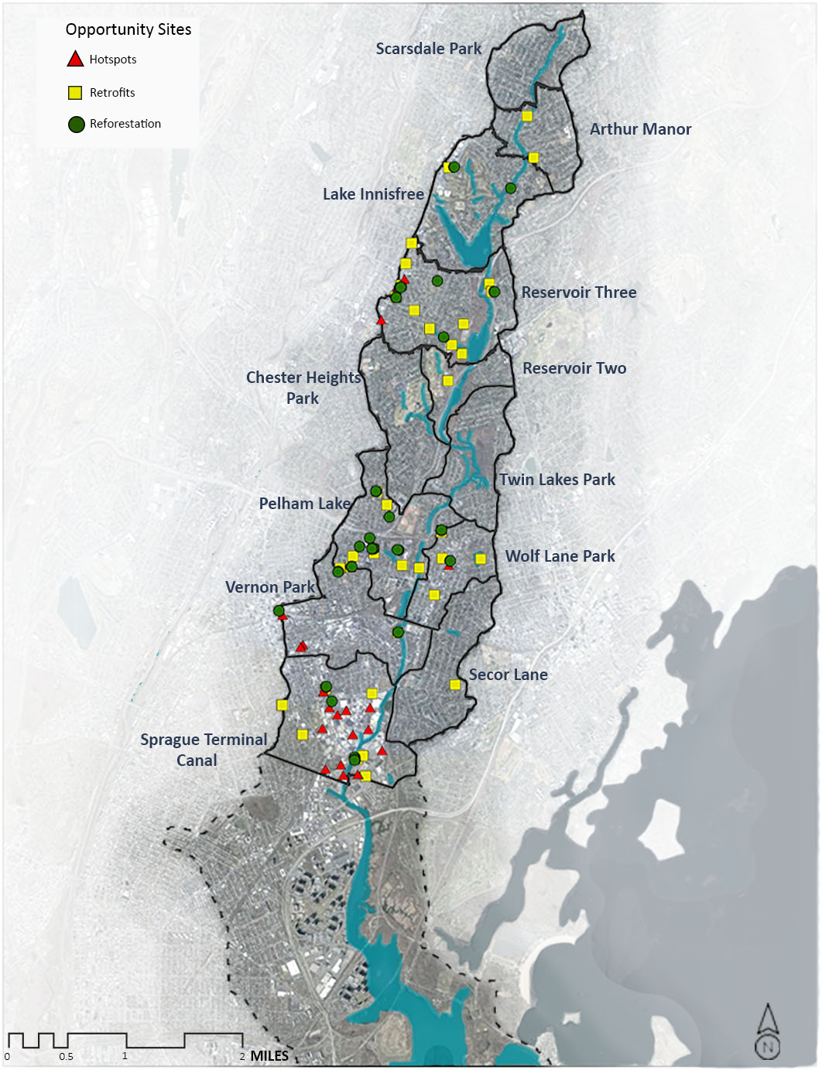
Figure 1. Field Assessment Sites

The field assessment resulted in the evaluation of 20 hotspots, 37 stormwater retrofits, and 25 reforestation sites. Subwatersheds Pelham Lake, Reservoir Three, Sprague Terminal Canal, and Vernon Park were thoroughly analyzed to find the most advantageous sites prior to field work. Save the Sound supplemented Biohabitats’ field assessments by analyzing and visiting opportunity sites in Arthur Manor, Vernon Park, and Wolfs Lane Park. Additional locations in other subwatersheds observed while out in the field were also included.
Table 1. Summary of Field Assessment Findings
Assessment | General Findings
Hotspot | - Twenty hotspot sites investigated  - Assessed areas from windshield or right-of-way  - Types of business assessed included:  - Auto body shops  - Shopping centers  - Scrap metal  - Stockpiling areas  - Asphalt production  - Common recommendations included street sweeping, dumpster replacement, future education, follow up meetings, bulk material management, oil and grease separator installation, and pavement replacement
Stormwater Retrofit | - Thirty-seven potential retrofit sites investigated  - Focused on water quality, nuisance flooding, and impervious area treatment  - Assessed mainly large parking lots, schools, playgrounds, and land owned by institutions (i.e., religious centers, schools)  - Types of retrofits included bioretention, perimeter sand filters, porous pavement, and wetlands
Reforestation | - Twenty-five potential reforestation sites investigated  - Focus on impervious areas and forest/grasses in poor condition  - Noted invasive presence for invasive removal recommendations  - Types of recommendations included reforestation, conservation landscaping, and street trees

Hotspot Assessment
The hotspot assessment, based on the Center for Watershed Protection’s Hotspot Site Investigation, evaluated commercial, industrial, municipal, and transport-related sites with high potential to contribute contaminated runoff to the storm drain system or receiving waters. At hotspot sites, field crews looked at vehicle operations, outdoor materials storage, waste management, building conditions, turf and
landscaping, and stormwater infrastructure to evaluate potential pollution sources. Table 2 includes a list of the types of hotspots sites assessed.

Table 2. Types of Hotspot Sites Assessed
Category | Description
Commercial | - Auto Repair Shops  - Car Washes | - Gas stations  - Dry Cleaners
Industrial | - Equipment and chemical storage  - Manufacturing plants | - Distribution Centers
Transportation Related | - Bus parking | - Train stations

Hotspots: Summary of Sites Assessed
While field crews were unable to assess all potential hotspot locations in the watershed, those considered provide a representative group of hotspot types. Recommendations from assessed hotspot sites can be applied to other sites with similar activities. Each hotspot site’s severity was assessed based on the types and extent of pollutants observed, exposure to rainfall, and the size of the impacted area. Each hotspot was evaluated for the following improvement opportunities:
- Future education: on proper pollution prevention practices, spill prevention, and basic stormwater management.
- Follow up: provide outreach to address the observed site conditions.
- Oil and grease separator installation
- Street sweeping: routine street sweeping to prevent debris from entering the storm drain system and nearby waterbodies.
- Trash management: education and methods for placing trash in the proper receptacles; trash receptacle location (away from storm drains where possible); and trash prevention planning.
- Dumpster replacement: replace dumpsters with larger, more sturdy ones that have lids that are able to close and retain more of the waste and reduce leakage to the storm drain system.
- Bulk material management: reorganization of bulk materials either inside, under cover, or with perimeter controls to prevent the migration of materials to the storm drain system and nearby waterbodies.
- Permeable pavers: replace degraded pavement with permeable pavers to allow for water to reenter the ground and slow runoff. In some cases, repaving the parking area may be warranted (vs utilizing permeable pavers).

Sites where the hotspot assessment was conducted are identified in Figure 2 and Table 3. A geodatabase of the field assessment data was delivered to the Westchester County (County) and Save the Sound (STS) in July 2023.
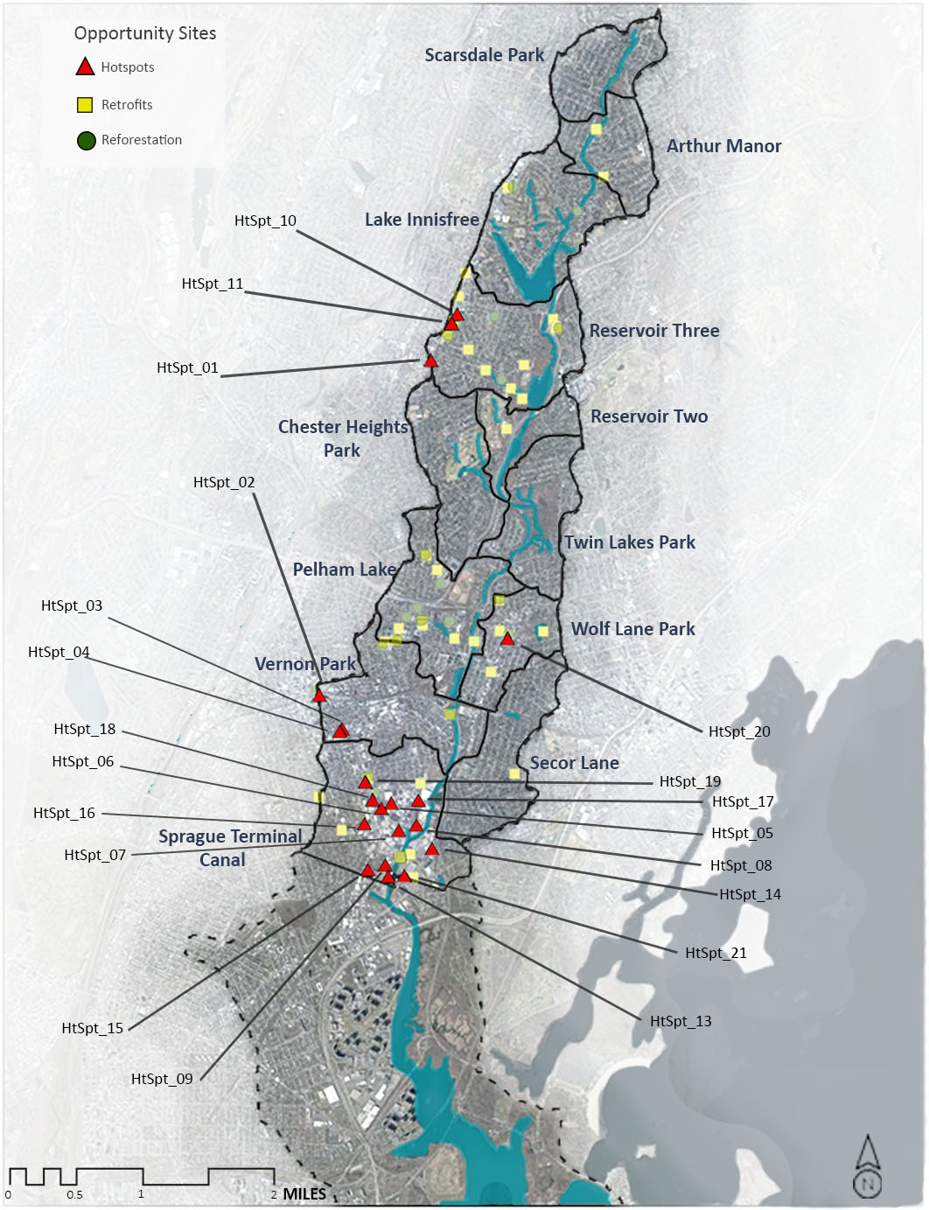
Figure 2. Assessed Hotspot Locations in the Hutchinson River Watershed

Table 3. Summary of Assessed Hotspot Locations
Hotspot ID | Site Name | Subwatershed
HtSpt_01 | Cornell Hardware Store | Reservoir Three
HtSpt_02 | Mt Vernon East Train Yard | Vernon Park
HtSpt_03 | Mega Mat Wash and Dry | Vernon Park
HtSpt_04 | Businesses along East Third Street | Vernon Park
HtSpt_05 | J Bass & Son Scrap Metal | Sprague Terminal Canal
HtSpt_06 | Yonkers Paving Facility | Sprague Terminal Canal
HtSpt_07 | Pro Asphalt | Sprague Terminal Canal
HtSpt_08 | Sprague Terminal Recycling | Sprague Terminal Canal
HtSpt_09 | Green Patch Asphalt Production | Sprague Terminal Canal
HtSpt_10 | Stop and Shop Dumpster Area | Reservoir Three
HtSpt_11 | CVS & Wells Fargo Dumpster | Reservoir Three
HtSpt_13 | SRM Concrete | Sprague Terminal Canal
HtSpt_14 | Ice hutch Parking Lot | Sprague Terminal Canal
HtSpt_15 | Manor Paving | Sprague Terminal Canal
HtSpt_16 | Roslyn Place Pavement | Sprague Terminal Canal
HtSpt_17 | TJ Maxx Shopping Area | Sprague Terminal Canal
HtSpt_18 | S Fulton Ave Materials Storage | Sprague Terminal Canal
HtSpt_19 | S Fulton Ave Parking lot | Sprague Terminal Canal
HtSpt_20 | M&M Auto Service | Wolfs Lane Park
HtSpt_21 | Mt Vernon Shipping Terminal | Wolfs Lane Park

General findings from the hotspot assessment include:
- There is a large variance in the severity of hotspot in the watershed ranging from very large industrial sites with large areas of exposed bulk materials to much smaller commercial sites with little to no outdoor activity.
- The biggest hotspots observed during the assessment included industrial asphalt production and large bulk storage facilities. Types of projects recommended for these sites include street sweeping, perimeter controls, and education projects.
- Many sites lacked dumpsters or had dumpsters in poor condition resulting in trash being left on the curb and overflowing from bags. Recommendations included targeted locations for dumpsters and better coordinated trash pick-up programs.
  - The watershed would benefit from either a dumpster replacement campaign and/or an education effort to keep dumpster lids closed/trash contained.
- Many locations’ parking lots were in disrepair resulting in large amounts of debris entering the storm drain system. Repaving parking lots or replacing asphalt with permeable pavers would decrease the debris entering the storm drain system.

Figures 3 - 7 illustrate the findings described above.

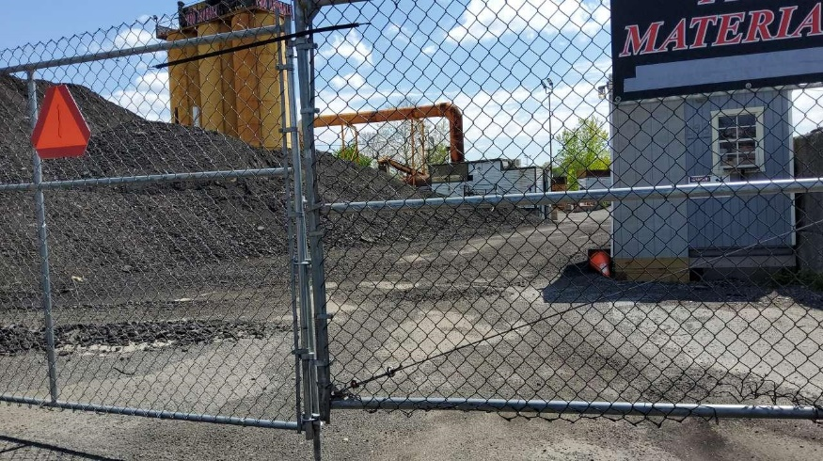
Figure 3. Uncontained Asphalt Piles

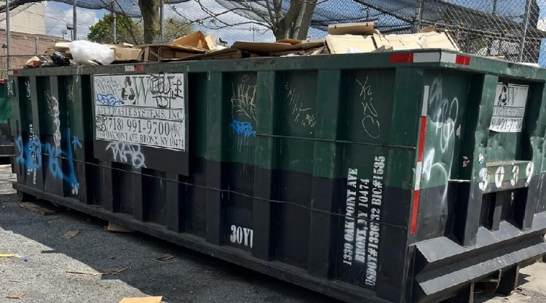 | 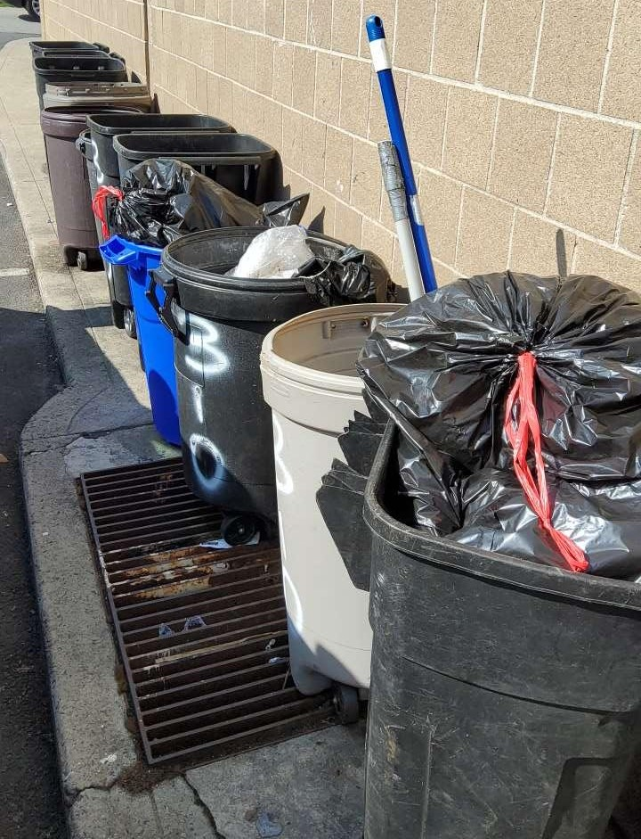
Figure 4. Poorly Located and Undersized Trash Containers

Figure 5. Exposed Materials throughout the Watershed

Figure 6. Unmaintained Pavement with Accumulating Debris

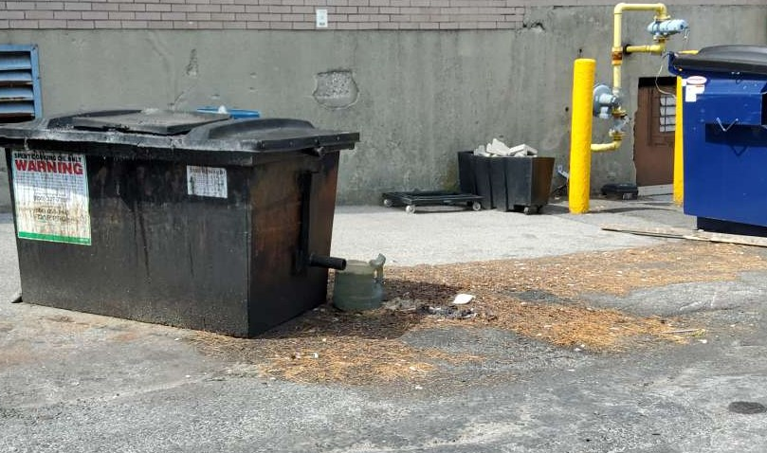
Figure 7. Large Grease Stains along Pavement

Stormwater Retrofit Assessment
Stormwater retrofits are structural stormwater management facilities inserted into the urban landscape where little to no stormwater management currently exists. The stormwater retrofit assessment identified opportunities throughout the watershed for storage retrofits and/or on-site retrofits. Storage retrofits, such as ponds and wetlands, provide the widest range of watershed restoration benefits by treating water quality and providing limited storage. On-site retrofit practices, such as bioretention and filtering practices, treat smaller drainage areas and can address small nuisance flooding concerns. Application of practices in the two categories varies according to the impervious cover, land use, and restoration goals being pursued.

Stormwater Retrofits: Summary of Sites Assessed
The field crew visited a total of thirty-seven sites with retrofit opportunities and drainage area delineations being created for each location including: Commercial Sites, Institutional sites, one Train Station, Natural Spaces, Residential Sites, and Streets. Candidate sites were initially identified using aerial imagery, local input, impervious cover analysis, and land use.

For the stormwater retrofit assessment, Biohabitats identified retrofits with the objective of providing water quality treatment, addressing nuisance flooding, and mitigating known localized channel erosion areas. Field crews looked at drainage patterns, the amount of impervious cover, available space, and other site constraints, such as utilities, when evaluating a site.

Figure 8 and Table 4 identifies stormwater retrofit assessment areas. A geodatabase of the field assessment data was delivered to the County and STS in July 2023.

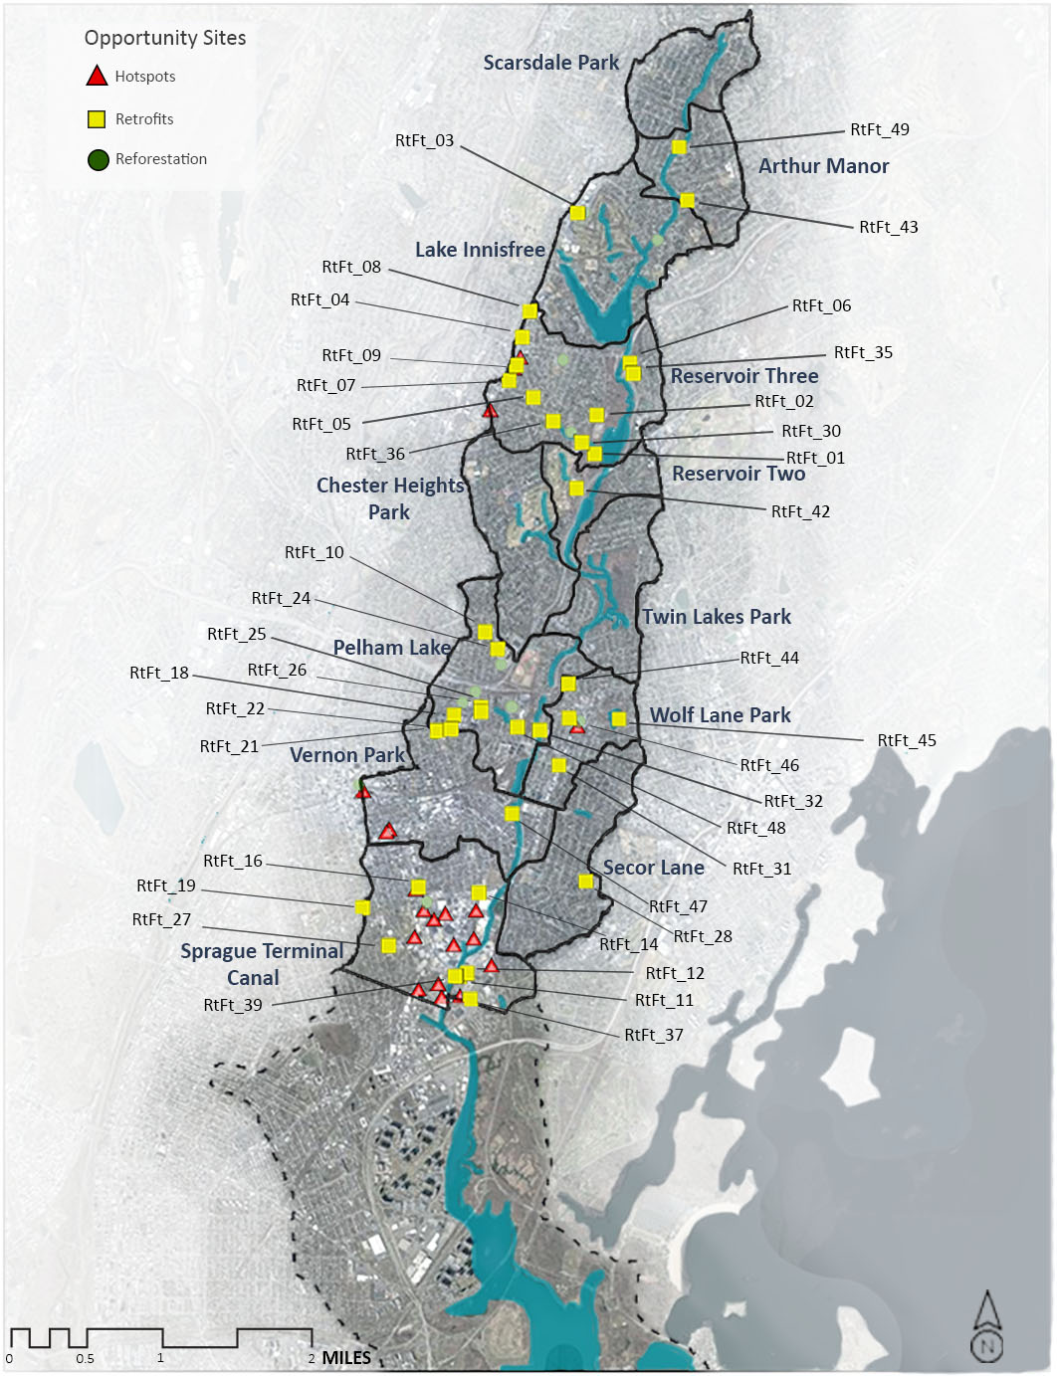
Figure 8. Retrofit Locations in the Hutchinson River Watershed

Table 4. Summary of Retrofit Sites
Retrofit ID | Site Name | Subwatershed | Proposed Stormwater Management Facility
RtFt_01 | Reservoir Three Shoreline | Reservoir Three | Wetland
RtFt_02 | Twin Lakes County Park | Reservoir Three | Wetland
RtFt_03 | Vernon Hill Shopping Center | Lake Innisfree | Bioretention
RtFt_04 | Eastchester Public Library | Reservoir Three | Bioretention
RtFt_05 | Joyce Park | Reservoir Three | Wetland
RtFt_06 | Holy Trinity Greek Orthodox Church Side Lawn | Reservoir Three | Wetland
RtFt_07 | Chase Bank | Reservoir Three | Bioretention
RtFt_08 | Garden Coop Apartments | Reservoir Three | Bioretention
RtFt_09 | Wells Fargo Lot | Reservoir Three | Bioretention
RtFt_10 | Muslim Center | Pelham Lake | Bioretention
RtFt_11 | Dave and Busters Parking Lot | Sprague Terminal Canal | Bioretention
RtFt_12 | Pelham Plaza Parking Lot | Sprague Terminal Canal | Bioretention
RtFt_14 | Sanford Blvd East Dunkin | Sprague Terminal Canal | Bioretention
RtFt_16 | Mt Vernon Fire Department | Sprague Terminal Canal | Wetland
RtFt_18 | Vernon Manor Coop Apts | Pelham Lake | Bioretention
RtFt_19 | Cecil E Parker Elem School | Sprague Terminal Canal | Bioretention
RtFt_21 | Presbyterian Church and Holmes School Shared Lot | Pelham Lake | Bioretention
RtFt_22 | Mt Vernon Fire Department | Pelham Lake | Bioretention
RtFt_24 | Mt Vernon High School | Pelham Lake | Wetland
RtFt_25 | Sheridan Ave Park | Pelham Lake | Bioretention
RtFt_26 | Sheridan Ave Street Median | Pelham Lake | Bioretention
RtFt_27 | Rebecca Turner Elementary School | Sprague Terminal Canal | Bioretention
RtFt_28 | Colonial Ave Shoulder | Secor Lane | Bioretention
RtFt_30 | Path Alongside Reservoir Three | Reservoir Three | Wetland
RtFt_31 | Pelham Art Center Parking Lot | Wolfs Lane Park | Bioretention
RtFt_32 | Hutchinson River Tributary from River Ave | Wolfs Lane Park | Regenerative Stormwater Conveyance
RtFt_35 | Holy Trinity Greek Orthodox Church Parking Lot | Reservoir Three | Bioretention
RtFt_36 | Eastchester Park | Reservoir Three | Regenerative Stormwater Conveyance
RtFt_37 | Homegoods Parking Lot | Sprague Terminal Canal | Bioretention
RtFt_42 | Twin Lakes Farm | Reservoir Three | Wetland
RtFt_43 | Wilmot Ave Daisy Farm | Reservoir Three | Bioretention
RtFt_44 | Chester Park | Wolfs Lane Park | Bioretention
RtFt_45 | Glenwood Lake | Wolfs Lane Park | Bioretention
RtFt_46 | Juliannes Playground | Wolfs Lane Park | Bioretention
RtFt_47 | Beechwood Ave | Vernon Park | Bioretention
RtFt_48 | Stream below Wartburg Home | Pelham Lake | Wetland
RtFt_49 | Sprague Rd | Arthur Manor | Bioretention

The majority of stormwater retrofit opportunities identified in the watershed are on large, paved parcels and public, highly visible locations. Specific types of stormwater management facilities prescribed for retrofit locations vary, but include bioretention practices, regenerative stormwater conveyance, sand filters, and wetlands.
General findings from the retrofit assessment include:
- Stormwater retrofit opportunities are being constructed along the Hutchinson River parkway in conjunction with highway improvement opportunities.
- Large flood protection projects have been implemented in the Pelham Lake portion of the Hutchinson River watershed, reducing flooding problems that were previously reported.
  - While there are some existing retrofit projects, there are abundant opportunities for onsite practices that could be incorporated in a manner that provides aesthetic improvement and educational opportunities to the site.
  - These sites would benefit from signage to share benefits of the project to the community.
- There are numerous opportunities for on-site stormwater retrofits throughout the watershed, particularly in parking lots and at publicly owned facilities.
  - Many of these sites appear to have underused parking lots and could potentially decrease their parking areas for retrofits and reforestation opportunities. Investigating the zoning laws for the size of parking lots will be required.
  - Additionally, redesigning parking lots, making them one way, to maintain the number of parking spots while increasing open space for retrofits should be considered.
- Wetland areas were viable in multiple locations, which have the dual benefit of providing water quality treatment and creating wildlife habitat within a very urban watershed.
Figures 9 - 13 illustrate some of the findings described above.

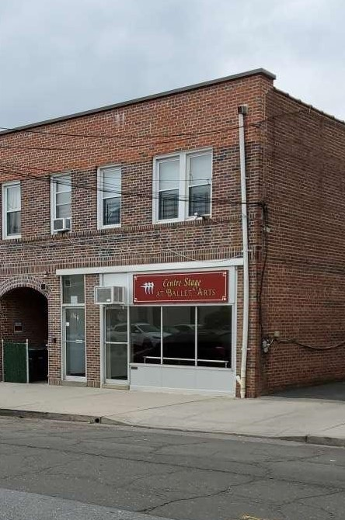 | 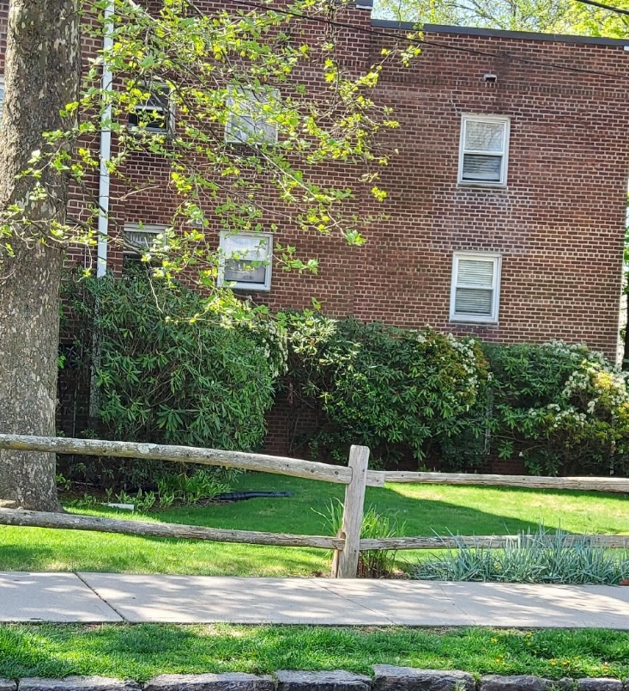
Figure 9. Buildings with External Downspouts are Good Opportunities for Planter Boxes

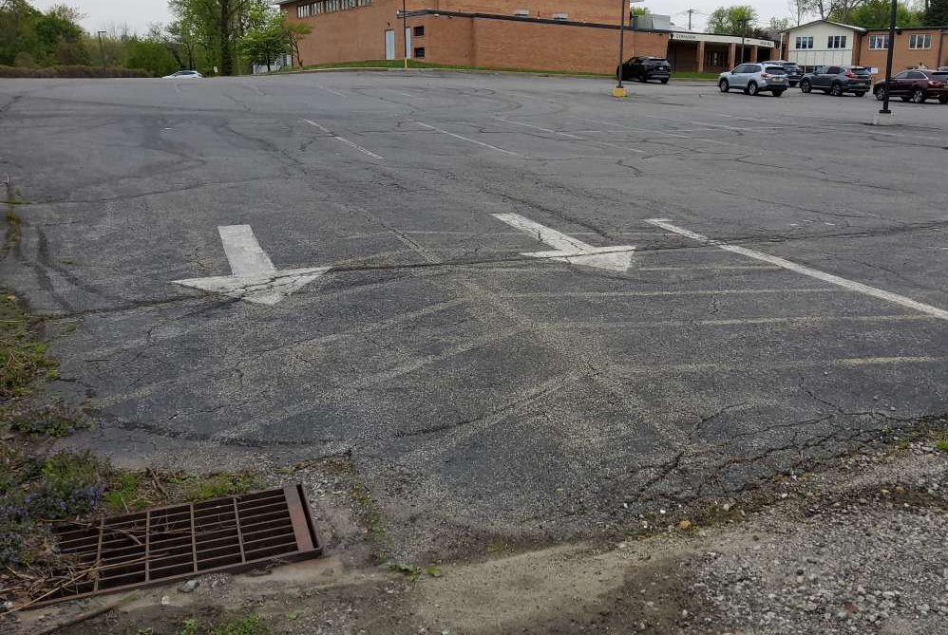 | 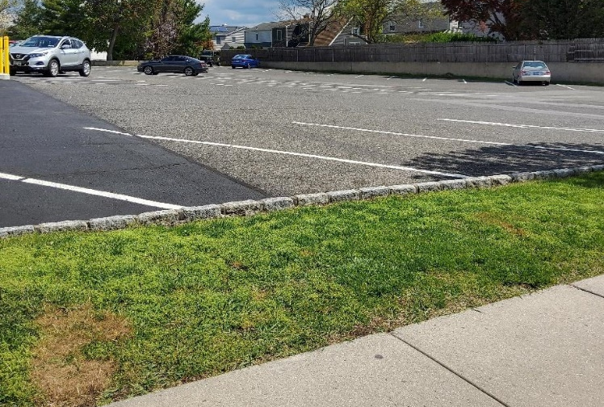
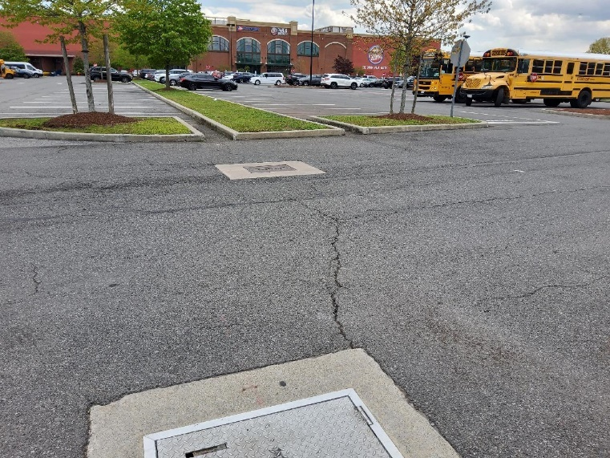 | 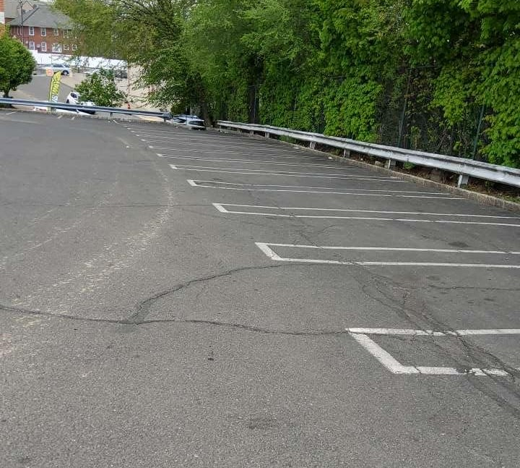
Figure 10. Large, Underutilized Parking Lots are a Stormwater Retrofit Opportunity

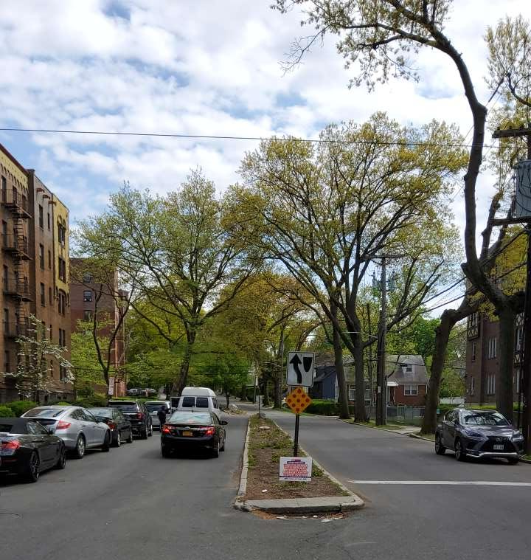
Figure 11. Wide Streets with Unmaintained Islands are a Green Streets Opportunity

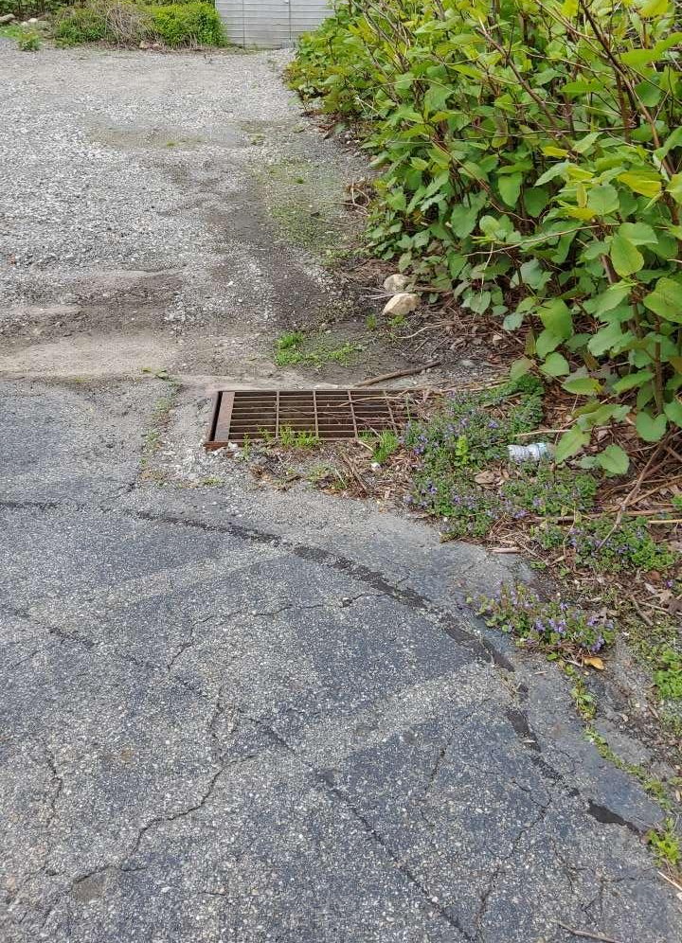 | 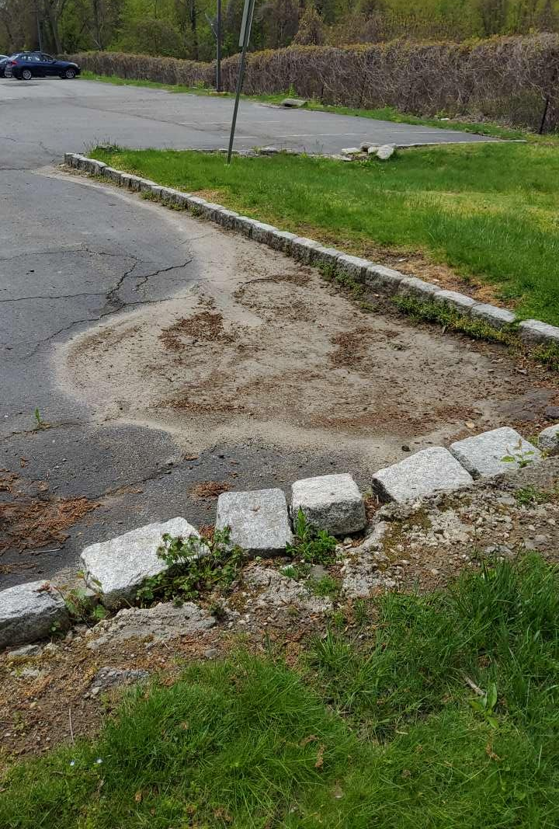
Figure 12. Locations with Evidence of Ponding Pose Good Opportunities for Bioretention
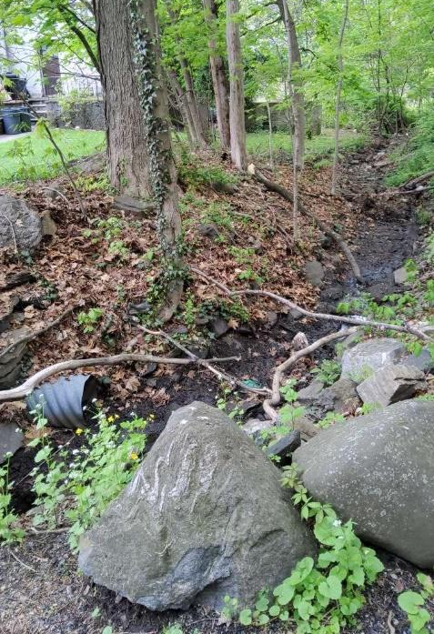 | 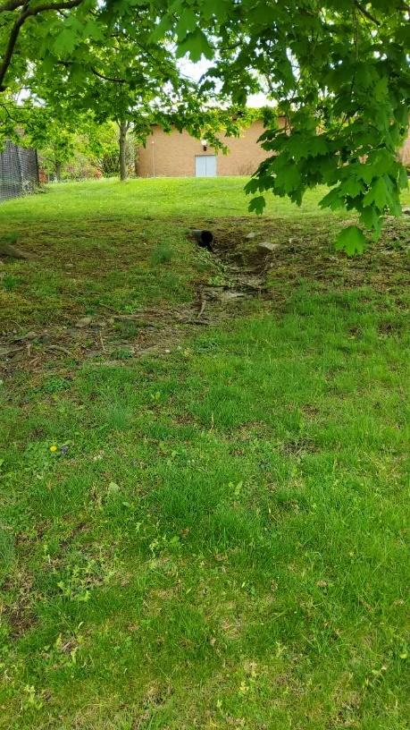
Figure 13. Opportunities for Regenerative Stormwater Conveyance (RSC)

Reforestation Assessment
The Reforestation Assessment was modified from the Center for Watershed Protection’s Urban Reforestation Site Assessment. The purpose of the Reforestation Assessment is to identify areas where:
- Forest fragments can be enhanced to the improve health, condition, and function of the urban forest.
- Open land can be reforested through active replanting or natural regeneration to regain some of the functions and benefits of a forest and to increase overall watershed forest cover and increase forest canopy.

Prior to going out into the field, publicly owned sites, and sites with large areas of turf grass were identified using aerial photos and land use mapping information.

Reforestation practices in an urban watershed such as the Hutchinson River range in size; smaller scale efforts such as street tree planting improve canopy cover and provide water quality treatment in areas with less available space. Conservation landscaping focuses on the introduction of native grasses and flowers to areas covered in turf grass to decrease runoff, and improve soil quality, carbon capture, and water quality. Reforestation focuses on large areas that can be restored as “urban forests” or are areas concentrated with trees or urban forests.

Reforestation: Summary of Sites Assessed
A total of 25 sites were evaluated by field crews for the potential to replace impervious cover with pervious areas, restore turf grass to meadow landscapes, increase tree canopy, and enhance the existing urban forest. Sites were deemed as stronger reforestation candidates if they were on larger parcels with minimal site preparation requirements, were under public ownership, or had potential linkage with other upland restoration opportunities such as stormwater retrofit.

Figure 14 and Table 5 identifies reforestation assessment areas. A geodatabase of the field assessment data was delivered to the County and STS in July 2023.

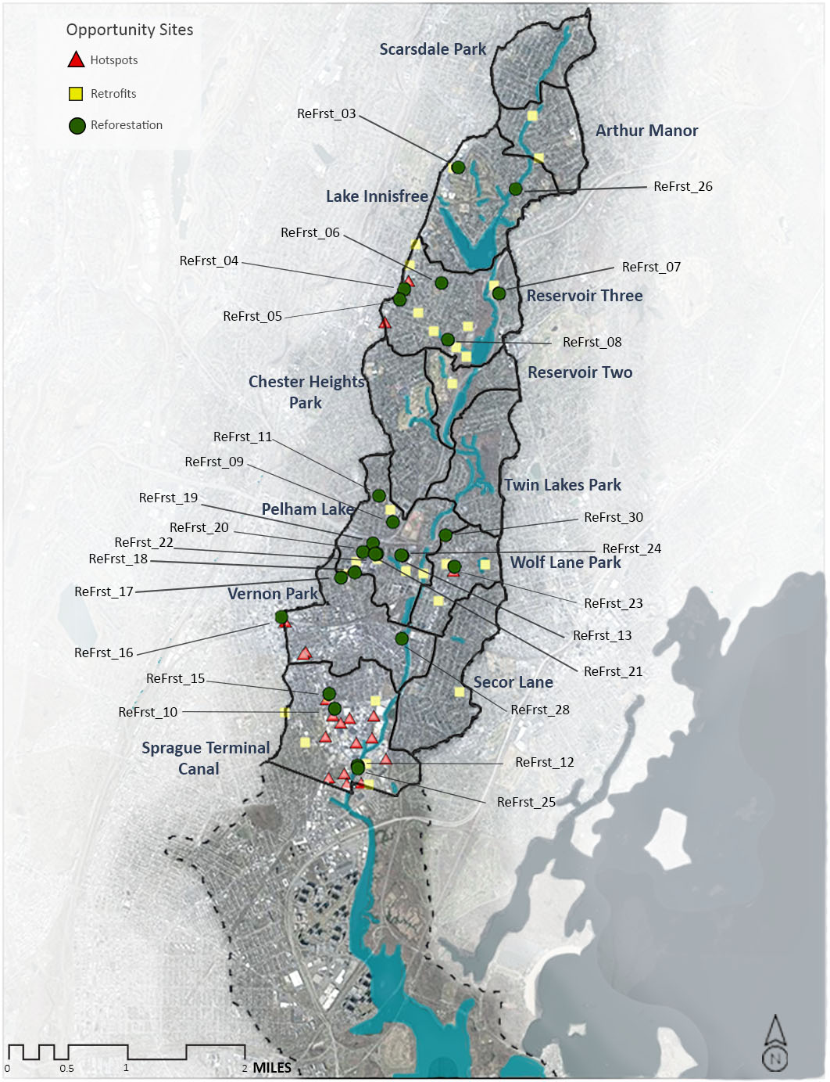
Figure 14. Reforestation Locations in the Hutchinson River Watershed

Table 5. Summary of Reforestation Opportunities
Reforestation ID | Site Name | Subwatershed | Proposed Reforestation Project Type
ReFrst_03 | Vernon Hills Shopping Center | Lake Innisfree | Reforestation
ReFrst_04 | Wells Fargo Lot | Reservoir Three | Reforestation
ReFrst_05 | Chase Bank Lot | Reservoir Three | Reforestation
ReFrst_06 | Anne Hutchinson Elementary School | Reservoir Three | Conservation Landscaping
ReFrst_07 | Greek Orthodox Holy Trinity Church | Reservoir Three | Reforestation
ReFrst_08 | Eastchester Park | Reservoir Three | Conservation Landscaping
ReFrst_09 | Mt Vernon High School | Pelham Lake | Conservation Landscaping
ReFrst_10 | Stop and Shop Parking Lot | Sprague Terminal Canal | Reforestation
ReFrst_11 | Muslim Center | Pelham Lake | Conservation Landscaping
ReFrst_12 | Hutchinson River Shoreside | Sprague Terminal Canal | Conservation Landscaping
ReFrst_13 | Wartburg Retirement Home II | Pelham Lake | Conservation Landscaping
ReFrst_15 | Open, Unused Lot | Sprague Terminal Canal | Conservation Landscaping
ReFrst_16 | Mt Vernon East Train Station | Vernon Park | Conservation Landscaping
ReFrst_17 | Holmes Elementary School | Vernon Park | Conservation Landscaping
ReFrst_18 | Mt Vernon Fire Department | Pelham Lake | Conservation Landscaping
ReFrst_19 | Traphagen School II | Pelham Lake | Reforestation
ReFrst_20 | Traphagen School I | Pelham Lake | Conservation Landscaping
ReFrst_21 | Sheridan Ave Park I | Pelham Lake | Conservation Landscaping
ReFrst_22 | Sheridan Ave Park II | Pelham Lake | Conservation Landscaping
ReFrst_23 | 5th Ave Businesses | Wolfs Lane Park | Street Trees
ReFrst_24 | Wartburg Retirement Home I | Pelham Lake | Street Trees
ReFrst_25 | Dave and Busters Parking Lot | Sprague Terminal Canal | Street Trees
ReFrst_26 | Wilmot Rd @ Old Wilmot | Lake Innisfree | Reforestation
ReFrst_28 | Beechwood Ave Grassy Curb | Vernon Park | Conservation Landscaping
ReFrst_30 | Chester Park | Wolfs Lane Park | Conservation Landscaping

General findings from the reforestation assessment include:
- Additional opportunities for reforestation, street trees, and conservation landscaping exist throughout the watershed. Within the priority subwatersheds, these were the most viable reforestation opportunities.
- The parcel areas for reforestation are relatively small but in the context of such an urban watershed can have large impact.
  - Many reforestation opportunities are within parking lots that appear to be underutilized, which may warrant thinking about how zoning codes and ordinances influence the design and size of parking lots.
- Conservation landscaping is largely recommended on school grounds where underutilized turf exists. Recommendations took into consideration active play and sports areas; opportunities identified areas for outreach and education and more discovery-oriented play spaces.
- Street trees are identified in areas where they can provide additional benefits such as cooling capacity, pavement maintenance, and improved aesthetics.
  - There is high potential for green street programs as well.

Figures 15 and 16 below illustrate some of the findings described above.

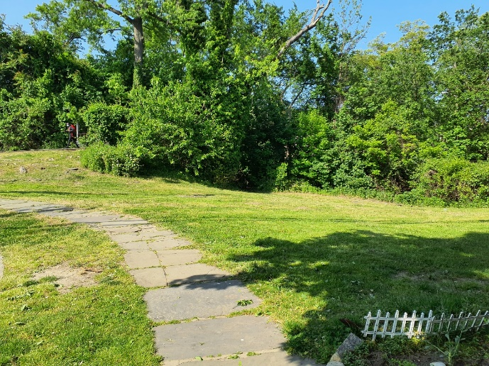 | 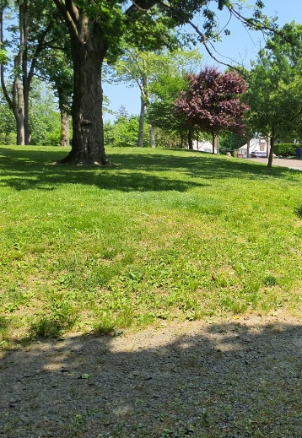
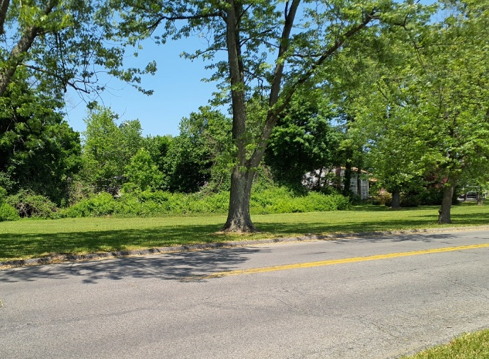
Figure 15. Reforestation Opportunities Located in Pervious Areas Adjacent to Existing Tree Canopy

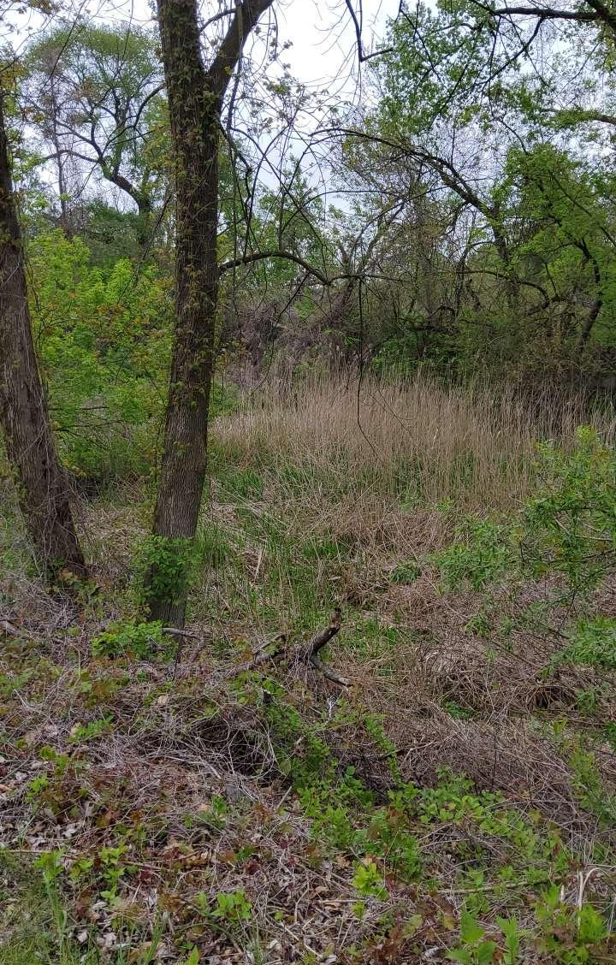 | 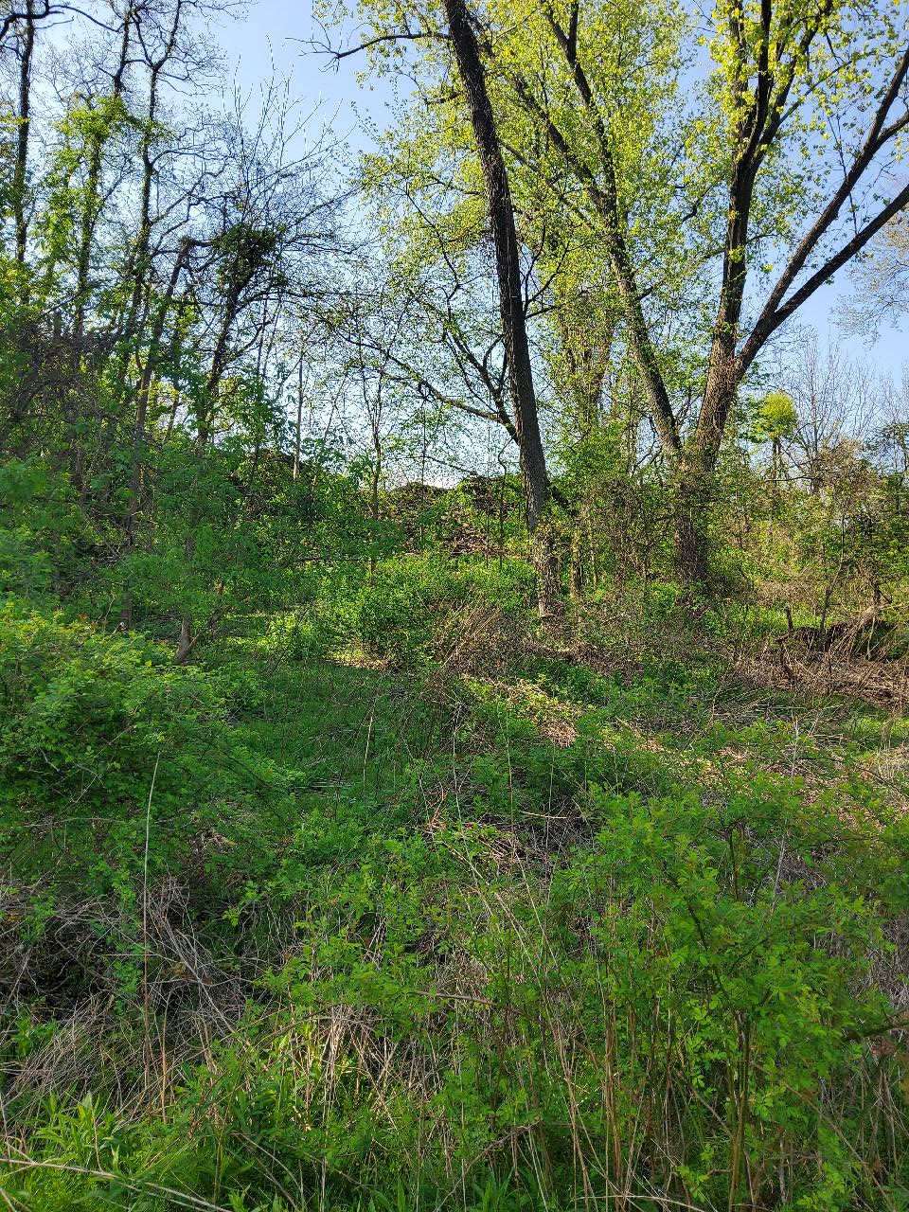
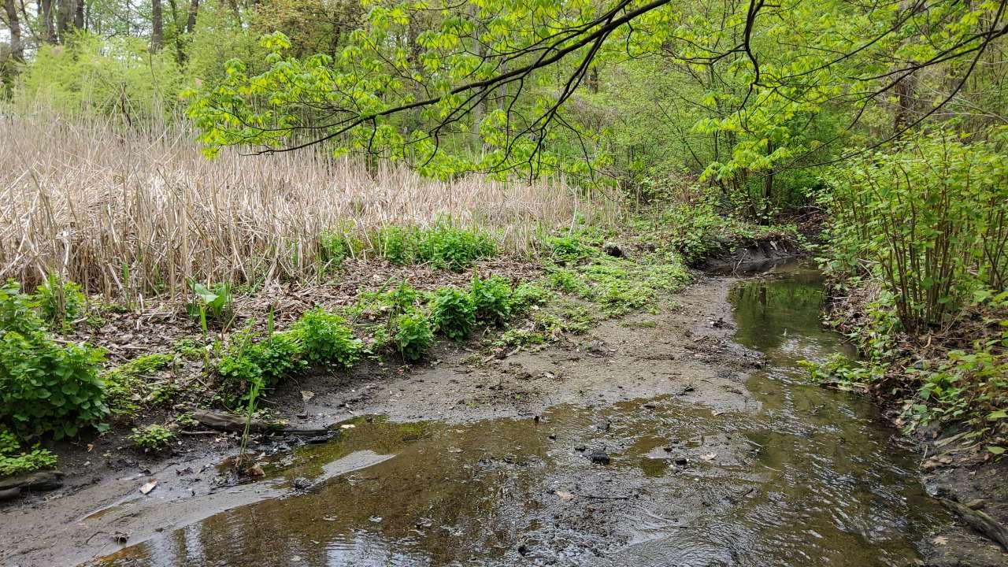

Figure 16. Reforestation Enhance Opportunities including Areas Identified for Invasives Species Removal

Restoration Opportunities Prioritization Methodology
Based on data collected through the field assessments, an inventory of restoration opportunities was developed. Biohabitats worked with Save the Sounds, Westchester County, and the Watershed Steering Committee to develop a schema to prioritize and rank restoration opportunities using the desktop and field assessment data. While the individual metrics vary by type of opportunity, the overall prioritization framework for all three (Hotspots, Retrofits, and Reforestation) organized into the following categories:
- Environmental Impact: covers metrics that are focused on the project’s environmental impact. Water quality is a large focus of this category. Additional metrics are included depending on the project type.
- Ability to Address: considers the feasibility or ease of implementing the proposed opportunity, including ownership and physical parameters such as available space, slope and soil type.
- Ancillary Benefits: considers additional benefits that may result from the project’s implementation.

Restoration opportunities were scored within each of the categories to determine a total score that assigns each opportunity as either high, medium, or low priority within each restoration opportunity type. The following section provides additional detail on the scoring metrics utilized for each type of opportunity.

Hotspot Prioritization Metrics
Metrics considered in the prioritization of hotspot sites are described below.

Hotspots: Environmental Impacts
Environmental impacts scoring was largely based on field observations of hotspot sites in the field and included Contributing Pollutants of Concern (POC) and Severity.
- Contributing POCs: scores a site’s potential to contribute to the pollutants on Hutchinson River watershed’s 303d list of impaired waters (low dissolved oxygen, fecal coliform, and oil and grease).
- Severity: based on the site’s size and amount and type of exposed materials. The scoring breakdown for each of the factors is summarized in Table 6.
Table 6. Hotspot Environmental Impacts Scoring Criteria
Criteria | Points  (Total Possible Pts: 30)
Contributing POCs
Multiple POCs Observed | 10
One POC Observed | 5
No POCs Observed | 0
Severity
High | 20
Medium | 10
Low | 0

Hotspots: Ability to Address
Metrics under the ability to address category included the following:
- NPDES Permit Coverage: Facilities with coverage under the Stormwater Multi-Sector General Permit already have requirements to prevent and reduce stormwater pollution from onsite activities. Facilities with coverage under this permit may be more amenable to assistance and outreach regarding improvement of onsite practices to reduce stormwater pollution.
- Ease of Implementation: Based on field observations of the feasibility of implementation including physical parameters such as space and onsite activities.
- Ownership: Tax parcel data was analyzed to determine the ownership of the potential sites. This metric is important because some owners (for example, Westchester County), will provide fewer logistics barriers than a private owner. Other Public land is defined as land owned by towns, NY state, and federal land. Institutional land is defined as a private owner that is not a single-family home (religious centers, private schools, etc.).
- Cost: The field assessment identified recommendations for each site with most sites having multiple recommendations. For the purposes of prioritization, a ballpark cost was assigned to each type of recommendation. Cost will vary depending on the site and nature and extent of activities at each site. A summary of the costs assigned to each recommendation type is provided in Table 8. Projects with costs over $105,000 were deemed to be High costs; projects with costs between $105,000 and $50,000 were deemed to be Medium Cost; and projects with costs less than $50,000 were Low Cost.
The scoring breakdown for each of the factors is summarized in Table 7.
Table 7. Hotspot Ability to Address Scoring
Criteria | Points  (Total Possible Pts: 25)
NPDES Permit Coverage
Yes | 5
No | 0
Ease of Implementation
High | 7
Medium | 5
Low | 0
Ownership
Westchester County | 8
Other Public | 7
Institutional | 3
Private | 0
Cost
Low | 5
Medium | 3
High | 0

Table 8. Hotspot Recommendations High Level Cost Estimates
Recommendation Type | Unit Cost Estimate | Additional Notes
Outreach | $2,500 | Staff time for two full day visits per year.
Dumpster replacement | $1,200
Bulk material perimeter control | $20,000
Resurfacing parking lot | $45,000 | Assuming the cost is $2/square foot and 1-2 acres of parking lot will be resurfaced.
Weekly street sweeping | $5,200 | Two sweepings per week per year costing $50 per visit.
Oil and Grease Separator | $60,000 | Cost varies greatly depending on the drainage area and size of the oil and grease separator. Costs also assume that one oil and grease separator is installed at a site. Costs are based on King and Hagan (2011) and adjusted for inflation.

Hotspots: Ancillary Benefits
Additional benefits considered as a result of implementing hotspot recommendations included:
- Ability to Combine with Other Opportunities: This metric considered the presence of other opportunity types located on the same parcel. For example, if one parcel with a reforestation opportunity was also identified as a retrofit opportunity. A summary of hotspot opportunities co-located within another opportunity type is provided in Table 10.
- Visibility: This metric considered how visible a potential project might be to the public. Considerations included proximity to the street, whether volunteer efforts are possible during the implementation effort, and how often the site will be engaged with by the community.

The scoring breakdown for each of the factors is summarized in Table 9.

Table 9. Hotspot Ancillary Benefits Scoring
Criteria | Points  (Total Possible Pts: 12)
Ability to Combine
Yes | 5
No | 0
Visibility
High | 7
Medium | 5
Low | 0

Hotspot opportunities that are on the same parcel as other restoration opportunities are shown in Table 10.
Table 10. Hotspot Opportunities Co-Located with Other Opportunity Types
Hotspot Opportunity | Co-Located Opportunity(ies)
HtSpt_02: Mt Vernon East Train Yard | ReFrst_16: Mt Vernon East Train Station
HtSpt_11: CVS & Wells Fargo Dumpster | RtFt_09: Wells Fargo Lot  ReFrst_04: Wells Fargo Lot
HtSpt_20: M&M Auto Service | ReFrst_20: 5th Ave Businesses

Stormwater Retrofits
Metrics considered in the prioritization of retrofit sites are described below.

Stormwater Retrofits: Environmental Impacts
The environmental impacts of the retrofit opportunities were scored on the following metrics:
- Proposed BMP Type: As part of the field assessment, a proposed BMP type was identified based on-site conditions. Scoring is based on the proposed BMP type’s ability to provide both water quality treatment and/or habitat enhancement.
- Observed Flooding: The observed flooding metric was based on field observations of evidence of nuisance (e.g., staining near storm drain) or major flooding (e.g., sandbags) events at the location of the proposed BMP.
- Water Treatment Ratio: approximated the potential water quality treatment provided by the proposed BMP. Field and desktop data were utilized to approximate a footprint and drainage area for each proposed BMP. The BMP footprint and drainage area were compared to create a water treatment ratio to identify the level of potential water quality treatment provided at a site. This ratio was used to place potential retrofits into one of three bins:
  - Potential for Extra Treatment: the BMP footprint was more than 10% of the drainage area.
  - Full Treatment Likely: the BMP footprint was between 5 and 10% of the drainage area.
  - Partial Treatment Likely: the BMP footprint was less than 5% of the drainage area.
The scoring breakdown for each of the factors is summarized in Table 11.

Table 11. Stormwater Retrofit Environmental Impacts Scoring Criteria
Criteria | Points  (Total Possible Pts: 40)
Proposed BMP Type
Wetlands | 10
Bioretention, Stream Restoration, Regenerative Stormwater Conveyance | 5
None | 0
Observed Flooding
Major Flooding | 20
Nuisance Flooding | 10
None | 0
Water Treatment Ratio
Potential for Extra Treatment Likely | 10
Full Treatment Likely | 7
Partial Treatment Likely | 0

Stormwater Retrofits: Ability to Address
Metrics under the ability to address category included the following:
- Ease of Implementation: This metric utilized data compiled during field work to determine how difficult it would be to implement the retrofit effort at that site. Considerations included proximity to roads, natural resources, property boundaries, presence of steep slopes and utilities, and access.
- Ownership: Tax parcel data was analyzed to determine the ownership of the potential sites. This metric is important because some owners (for example, Westchester County), will provide fewer logistics barriers than a private owner. Other Public land is defined as land owned by towns, NY state, and federal land. Institutional land is defined as a private owner that is not a single-family home (religious centers, private schools, etc.).
- Cost: Planning level construction costs were estimated for the various project types depending on their estimated footprint or length. To provide conservative estimates, costs were increased by 20% to account for inflation. Cost assumptions were taken from previous similar projects. Table 13 provides the assumptions used for each BMP type. Projects with costs over $300,000 were deemed to be High costs; projects with costs between $150,000 and $300,000 were deemed to be Medium Cost; and projects with costs less than $150,000 were Low Cost.

The scoring breakdown for each of the factors is summarized in Table 12.

Table 12. Stormwater Retrofit Ability to Address Scoring
Criteria | Points  (Total Possible Pts: 20)
Ease of Implementation
High | 7
Medium | 5
Low | 0
Ownership
Westchester County | 8
Other Public | 7
Institutional | 3
Private | 0
Cost
Low | 5
Medium | 3
High | 0

Table 13. Stormwater Retrofit Planning Level Cost Estimate Assumptions
BMP Type | Cost Assumptions
Bioretention | Soil: $20/cubic foot  Plants: $10/square foot  Overflow Structure: $10,000  Erosion and Sediment Control: 20% of costs or $12,000 minimum
Regenerative Stormwater Conveyance | $700/linear foot
Stream Restoration | $1000/linear foot
Wetland | Soil: $10/cubic foot  Plants: $12/square foot  Overflow Structure: $10,000  Erosion and Sediment Control: 20% of costs or $12,000 minimum

Stormwater Retrofits: Ancillary Benefits
Metrics under the ancillary benefits category included the following:
- Ability to Combine with Other Opportunities: This metric considered the presence of other intervention types located on the same parcel. For example, if one parcel with a reforestation opportunity was also deemed fit to have a retrofit located there. A summary of hotspot opportunities co-located within another opportunity type is provided in Table 15.
- Visibility: This metric considered how visible a potential project might be to the public. The team considered proximity to the street, whether volunteer efforts are possible during the implementation effort, and how often the site will be engaged with by the community.
The scoring breakdown for each of the factors is summarized in Table 14.

Table 14. Stormwater Retrofit Ancillary Benefits Scoring
Criteria | Points  (Total Possible Pts: 12)
Ability to Combine
Yes | 5
No | 0
Visibility
High | 7
Medium | 5
Low | 0

Retrofit opportunities that are on the same parcel as other restoration opportunities are shown in Table 15.
Table 15. Stormwater Retrofit Opportunities Co-Located with Other Opportunity Types
Stormwater Retrofit Opportunity | Co-Located Opportunity(ies)
RtFt_01: Reservoir Three Shoreline | RtFt_02: Twin Lakes County Park  RtFt_30: Path Alongside Reservoir Three  RtFt_42: Twin Lakes Farm
RtFt_02: Twin Lakes County Park | RtFt_01: Reservoir Three Shoreline  RtFt_30: Path Alongside Reservoir Three  RtFt_42: Twin Lakes Farm
RtFt_03: Vernon Hill Shopping Center | ReFrst: Vernon Hills Shopping Center
RtFt_05 : Joyce Park | Stream Restoration and Wetland Opportunities at this Site.
RtFt_06 : Holy Trinity Greek Orthodox Church Side Lawn | ReFrst_07: Holy Trinity Greek Orthodox Church  RtFt_35: Holy Trinity Greek Orthodox Church Parking Lot
RtFt_07: Chase Bank | ReFrst: Chase Bank
RtFt_09: Wells Fargo Lot | HtSpt_11: CVS & Wells Fargo Dumpster  ReFrst04: Wells Fargo Lot
RtFt_10: Muslim Center | ReFrst_11: Muslim Center
RtFt_11: Dave and Busters Parking Lot | ReFrst_12: Hutchinson River Shoreside  ReFrst_25: Dave and Busters Parking Lot
RtFt_21: Presbyterian Church and Holmes School Shared Lot | ReFrst_17: Holmes Elementary School
RtFt_22: Mt Vernon Fire Department | ReFrst_18: Mt Vernon Fire Department
RtFt_24: Mt Vernon High School | ReFrst_09: Mt Vernon High School
RtFt_25: Sheridan Ave Park | ReFrst_21: Sheridan Ave Park I  ReFrst_22: Sheridan Ave Park II
RtFt_30: Path Alongside Reservoir Three | RtFt_01: Reservoir Three Shoreline  RtFt_02: Twin Lakes County Park  RtFt_42: Twin Lakes Farm
RtFt_35: Holy Trinity Greek Orthodox Church Parking Lot | ReFrst_07: Holy Trinity Greek Orthodox Church  RtFt_06: Holy Trinity Greek Orthodox Church Side Lawn
RtFt_37: Homegoods Parking Lot | Multiple locations on the Site for Retrofit Opportunities
RtFt_42: Twin Lakes Farm | RtFt_01: Reservoir Three Shoreline  RtFt_02: Twin Lakes County Park  RtFt_30: Path Alongside Reservoir Three
RtFt_44: Chester Park | ReFrst_30: Chester Park
RtFt_47: Beechwood Ave | ReFrst_28: Beechwood Ave Grassy Curb

Reforestation
Metrics considered in the prioritization of reforestation sites are described below.

Reforestation: Environmental Impacts
The environmental impacts of proposed reforestation projects were based on the size of the project area, project type and the presence of invasive species.
- Project Area: the proposed project area metric approximated the amount of land that could be restored in a reforestation effort. Sites were categorized as follows:
  - Large reforestation efforts covered over 0.35 acres (15,000 square feet)
  - Medium reforestation efforts covered over 0.08 acres (3,400 square feet)
  - Small reforestation efforts covered less than 0.08 acres (3,400 square feet)
- Project Type: the project type was based on field observations to determine the type of reforestation best suited for the site.
  - Reforestation efforts comprise of high-density tree and shrub planting in areas that are currently turf grass or impervious surfaces.
  - Conservation Landscaping efforts comprise of tall grass meadowlands and some trees.
  - Street Tree efforts comprise of single trees along roads and sidewalks to provide shade and water quality improvements.
- Invasives Presence: The invasive presence metric was based on field observations that determined the percentage of invasive coverage located at the site, which presents an opportunity to improve and enhance onsite habitat. Sites were categorized as follows:
  - High invasives presence: over 60 percent invasives coverage
  - Medium invasives presence: over 20 percent invasives coverage
  - Low invasives presence: less than 20 percent invasives coverage

The scoring breakdown for each of the factors is summarized in Table 16.

Table 16. Reforestation Environmental Impacts Scoring Criteria
Criteria | Points  (Total Possible Pts: 30)
Project Area
Large | 15
Medium | 7
Small | 1
Project Type
Reforestation | 10
Conservation Landscaping | 7
Street Trees | 3
Presence of Invasive Species
High | 5
Medium | 3
Low | 0

Reforestation: Ability to Address
Metrics under the ability to address category included the following:
- Ownership: Tax parcel data was analyzed to determine the ownership of the potential sites. This metric is important because some owners (for example, Westchester County), will provide fewer logistics barriers than a private owner. Other Public land is defined as land owned by towns, NY state, and federal land. Institutional land is defined as a private owner that is not a single-family home (religious centers, private schools, etc.).
- Ease of Implementation: This metric utilized data compiled during field work to determine how difficult it would be to implement the reforestation effort at that site. Considerations included the ability to include volunteers in reforestation efforts, the proximity to a water source, and the presence of any physical constraints (utilities, pavement, buildings, wires, lighting). If yes, the metric was given one point. The total scores were then divided into thirds as high, medium, and low.
- Cost: Costs were determined for the various project types depending on their estimated footprint. Cost assumptions were taken from previous similar projects. The following table provides the assumptions used for each Reforestation type. Costs are based off of the existing land use and apply to both conservation landscaping and reforestation. Projects with costs over $100,000 were deemed to be High costs; projects with costs between $30,000 and $100,000 were deemed to be Medium Cost; and projects with costs less than $30,000 were Low Cost. A summary of unit cost estimate is provided in Table 17.

Table 17. Reforestation Planning Level Cost Estimate Assumptions
Reforestation Type | Existing Land Use | Unit Cost
Reforestation and Conservation Landscaping | Open Space or Forest | $95,560 per acre
Reforestation or Conservation Landscaping | Paved | $265,000 per acre
Street Trees | All | $538 per tree

The scoring breakdown for each of the factors is summarized in Table 18.

Table 18. Reforestation Ability to Address Scoring
Criteria | Points  (Total Possible Pts: 20)
Ease of Implementation
High | 7
Medium | 5
Low | 0
Ownership
Westchester County | 8
Other Public | 7
Institutional | 3
Private | 0
Cost
Low | 5
Medium | 3
High | 0

Reforestation: Ancillary Benefits
Metrics under the ancillary benefits category included the following:

- Ability to Combine with Other Opportunities: This metric considered the presence of other opportunity types located on the same parcel. For example, if one parcel with a reforestation opportunity was also identified as a retrofit opportunity. A summary of hotspot opportunities co-located within another opportunity type is provided in Table 20.
- Visibility: This metric considered how visible a potential project might be to the public. The team considered proximity to the street, whether volunteer efforts are possible during the implementation effort, and how often the site will be engaged with by the community.
- Tree Canopy Cover: This metric considered whether an increase in canopy cover would occur as a result of the reforestation effort.

The scoring breakdown for each of the factors is summarized in Table 19.

Table 19. Reforestation Ancillary Benefits Scoring
Criteria | Points  (Total Possible Pts: 17)
Ability to Combine
Yes | 5
No | 0
Visibility
High | 7
Medium | 5
Low | 0
Tree Canopy Cover
Yes | 5
No | 0

Reforestation opportunities that are on the same parcel as other restoration opportunities are shown in Table 20.
Table 20. Reforestation Opportunities Co-Located with Other Opportunity Types
Reforestation Opportunity | Co-Located Opportunity(ies)
ReFrst_03: Vernon Hills Shopping Center | RtFt_03: Vernon Hills Shopping Center
ReFrst_04: Wells Fargo Lot | HtSpt_11: CVS & Wells Fargo Dumpster  RtFt_09: Wells Fargo Lot
ReFrst_05: Chase Bank Lot | RtFt_07: Chase Bank
ReFrst_07: Greek Orthodox Holy Trinity Church | RtFt_07: Holy Trinity Greek Orthodox Church  RtFt_35: Holy Trinity Greek Orthodox Church Parking Lot
ReFrst_09: Mt Vernon High School | RtFt_24: Mt Vernon High School
ReFrst_11: Muslim Center | RtFt_10: Muslim Center
ReFrst_12: Hutchinson River Shoreside | ReFrst_25: Dave and Busters Parking Lot  RtFt_11: Dave and Busters Parking Lot
ReFrst_13: Wartburg Retirement Home II | ReFrst_24: Wartburg Retirement Home I
ReFrst_16: Mt Vernon East Train Station | HtSpt_02: Mt Vernon East Train Yard
ReFrst_17: Holmes Elementary School | RtFt_21: Presbyterian Church and Holmes School Shared Lot
ReFrst_18: Mt Vernon Fire Department | RtFt_22: Mt Vernon Fire Department
ReFrst_19: Traphagen School II | ReFrst_20: Traphagen School I
ReFrst_20: Traphagen School I | ReFrst_19: Traphagen School II
ReFrst_21: Sheridan Ave Park I | ReFrst_22: Sheridan Ave Park II  RtFt_25: Sheridan Ave Park
ReFrst_22: Sheridan Ave Park II | ReFrst_21: Sheridan Ave Park I  RtFt_25: Sheridan Ave Park
ReFrst_23: 5th Ave Businesses | HtSpt_20: M&M Auto Service
ReFrst_24: Wartburg Retirement Home I | ReFrst_13: Wartburg Retirement Home II
ReFrst_25: Dave and Busters Parking Lot | RtFt_11: Dave and Busters Parking Lot  ReFrst_12: Hutchinson River Shoreside
ReFrst_28: Beechwood Ave Grassy Curb | RtFt_47: Beechwood Ave
ReFrst_30: Chester Park | RtFt_44: Chester Park

Restoration Opportunity Prioritization Results
A summary of the prioritization results, by opportunity type, is provided in Tables 21 – 23 and are depicted in Figures 18 – 20. Detailed scoring results can be found in Attachment A.

Table 21. Hotspot Opportunities Prioritization Summary
ID | Site Name | Environmental Score | Ability to Address Score | Ancillary Benefits Score | Total Score (Total Possible Pts: 67) | Prioritization
HtSpt_07 | Pro Asphalt | 25 | 8 | 7 | 40 | High
HtSpt_13 | SRM Concrete | 25 | 5 | 7 | 37 | High
HtSpt_20 | M&M Auto Service | 15 | 7 | 12 | 34 | High
HtSpt_08 | Sprague Terminal Recycling | 15 | 17 | 0 | 32 | High
HtSpt_04 | Businesses along East Third Street | 15 | 8 | 7 | 30 | High
HtSpt_09 | Green Patch Asphalt Production | 25 | 5 | 0 | 30 | High
HtSpt_10 | Stop and Shop Dumpster Area | 20 | 10 | 0 | 30 | High
HtSpt_06 | Yonkers Paving Facility | 15 | 10 | 5 | 30 | High
HtSpt_05 | J Bass & Son Scrap Metal | 15 | 13 | 0 | 28 | Medium
HtSpt_19 | S Fulton Ave Parking Lot | 15 | 7 | 5 | 27 | Medium
HtSpt_02 | Mt Vernon East Train Yard | 15 | 0 | 12 | 27 | Medium
HtSpt_16 | Roslyn Place Pavement | 5 | 12 | 7 | 24 | Medium
HtSpt_21 | Mt Vernon Shipping Terminal | 15 | 8 | 0 | 23 | Medium
HtSpt_15 | Manor Paving | 15 | 8 | 0 | 23 | Medium
HtSpt_14 | Ice hutch Parking Lot | 5 | 10 | 5 | 20 | Medium
HtSpt_11 | CVS & Wells Fargo Dumpster | 0 | 12 | 5 | 17 | Low
HtSpt_03 | Mega Mat Wash and Dry | 5 | 7 | 5 | 17 | Low
HtSpt_01 | Cornell Hardware Store | 0 | 12 | 0 | 12 | Low
HtSpt_17 | TJ Maxx Shopping Area | 0 | 12 | 0 | 12 | Low
HtSpt_18 | S Fulton Ave Materials Storage | 0 | 10 | 0 | 10 | Low

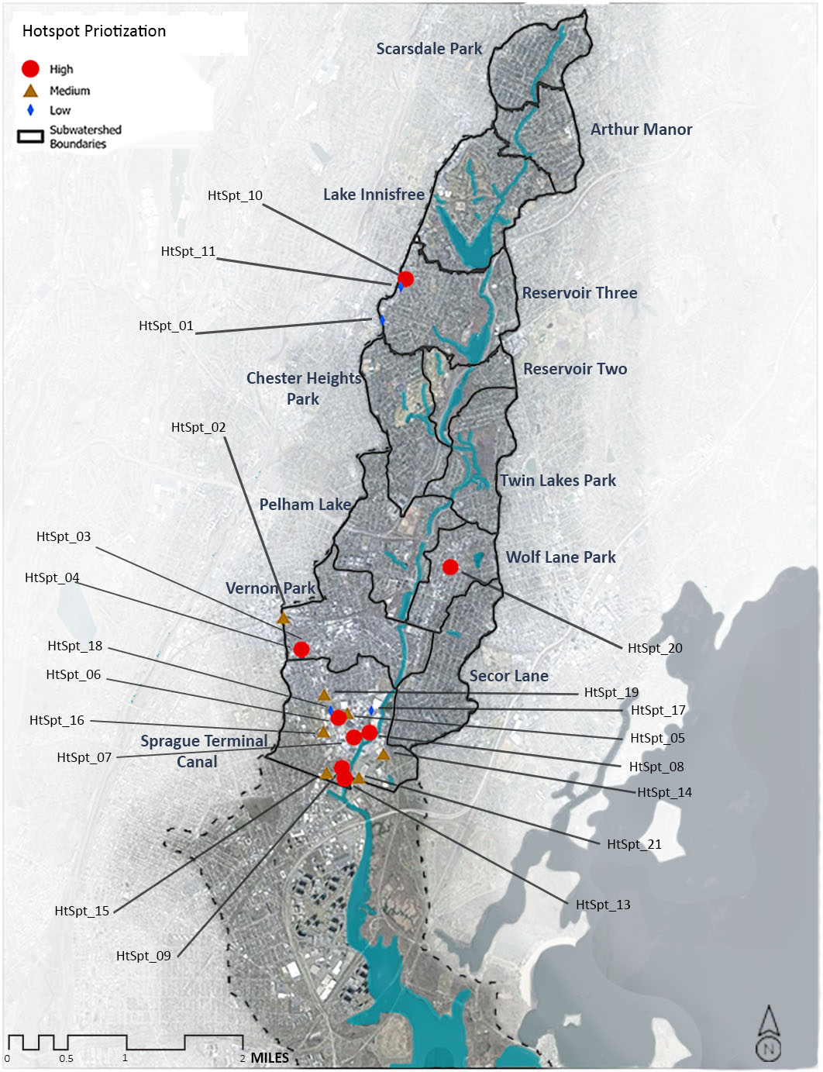
Figure 17. Hotspot Opportunities Based on Prioritization Ranking

Table 22. Stormwater Retrofit Opportunities Prioritization Summary
ID | Site Name | Environmental Score | Ability to Address Score | Ancillary Benefits Score | Total Score (Highest Possible Pts: 72) | Prioritization
RtFt_24 | Mt Vernon High School | 40 | 14 | 12 | 66 | High
RtFt_11 | Dave and Busters Parking Lot | 35 | 5 | 12 | 52 | High
RtFt_21 | Presbyterian Church and Holmes School Shared Lot | 25 | 12 | 12 | 49 | High
RtFt_27 | Rebecca Turner Elementary School | 25 | 15 | 7 | 47 | High
RtFt_31 | Pelham Art Center Parking Lot | 25 | 17 | 5 | 47 | High
RtFt_04 | Eastchester Public Library | 22 | 17 | 7 | 46 | High
RtFt_19 | Cecil E Parker Elementary School | 22 | 17 | 7 | 46 | High
RtFt_26 | Sheridan Ave Street Median | 22 | 17 | 7 | 46 | High
RtFt_06 | Holy Trinity Greek Orthodox Church Side Lawn | 30 | 10 | 5 | 45 | High
RtFt_16 | Mt Vernon Fire Department | 20 | 17 | 7 | 44 | High
RtFt_25 | Sheridan Ave Park | 15 | 17 | 12 | 44 | High
RtFt_47 | Beechwood Ave | 15 | 17 | 12 | 44 | High
RtFt_05 | Joyce Park | 20 | 12 | 10 | 42 | Medium
RtFt_28 | Colonial Ave Shoulder | 22 | 15 | 5 | 42 | Medium
RtFt_30 | Path Alongside Reservoir Three | 20 | 11 | 10 | 41 | Medium
RtFt_02 | Twin Lakes County Park | 20 | 11 | 10 | 41 | Medium
RtFt_35 | Holy Trinity Greek Orthodox Church Parking Lot | 15 | 15 | 10 | 40 | Medium
RtFt_22 | Mt Vernon Fire Department | 15 | 17 | 7 | 39 | Medium
RtFt_03 | Vernon Hill Shopping Center | 15 | 13 | 10 | 38 | Medium
RtFt_10 | Muslim Center | 15 | 13 | 10 | 38 | Medium
RtFt_48 | Stream below the Wartburg Home | 30 | 3 | 5 | 38 | Medium
RtFt_09 | Wells Fargo Lot | 22 | 10 | 5 | 37 | Medium
RtFt_37 | Homegoods Parking Lot | 25 | 7 | 5 | 37 | Medium
RtFt_46 | Juliannes Playground | 12 | 17 | 7 | 36 | Medium
RtFt_07 | Chase Bank | 22 | 8 | 5 | 35 | Medium
RtFt_18 | Vernon Manor Coop Apartments | 25 | 5 | 5 | 35 | Medium
RtFt_42 | Twin lakes Farm | 20 | 8 | 5 | 33 | Low
RtFt_49 | Sprague Rd | 15 | 12 | 5 | 32 | Low
RtFt_44 | Chester Park | 15 | 10 | 5 | 30 | Low
RtFt_12 | Pelham Plaza Parking lot | 22 | 8 | 0 | 30 | Low
RtFt_36 | Eastchester Park | 15 | 10 | 5 | 30 | Low
RtFt_08 | Garden Coop Apartments | 12 | 10 | 5 | 27 | Low
RtFt_14 | Sanford Blvd East Dunkin | 22 | 5 | 0 | 27 | Low
RtFt_01 | Reservoir Three Shoreline | 10 | 8 | 5 | 23 | Low
RtFt_45 | Glenwood Lake | 15 | 7 | 0 | 22 | Low
RtFt_43 | Wilmot Ave Daisy Farm | 5 | 10 | 5 | 20 | Low
RtFt_32 | Hutchinson River Tributary from River Ave | 5 | 12 | 0 | 17 | Low
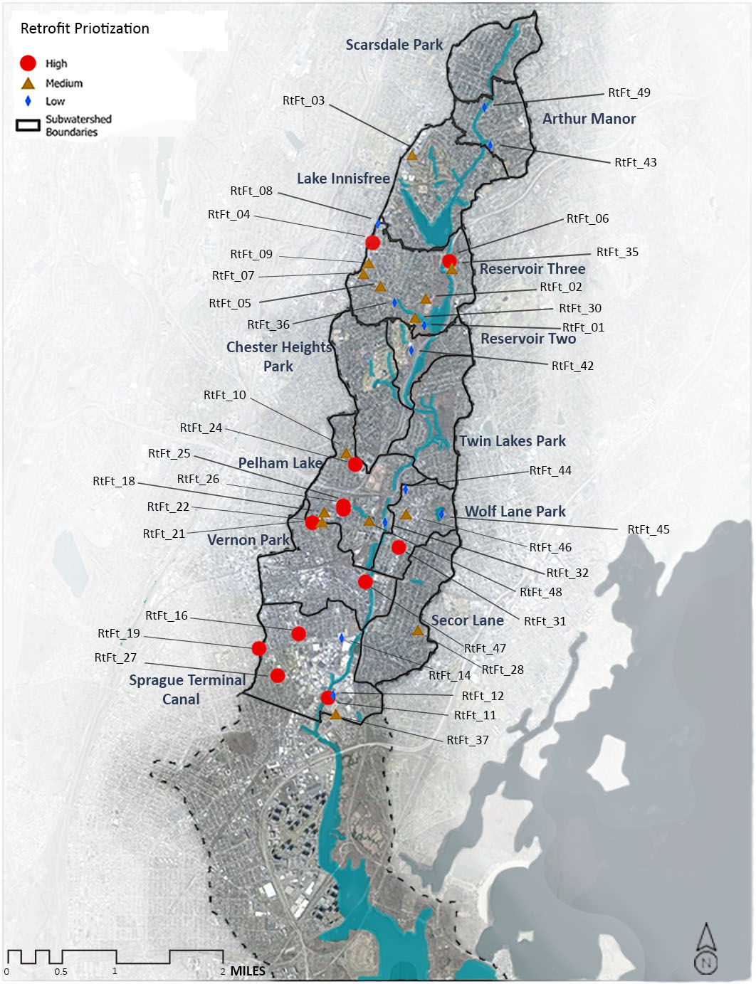
Figure 18. Retrofit Opportunities Based on Prioritization Ranking

Table 23. Reforestation Opportunities Prioritization Summary
ID | Site Name | Environmental Score | Ability to Address Score | Ancillary Benefits Score | Total Score (Highest Possible Score: 67) | Prioritization
ReFrst_28 | Beechwood Ave Grassy Curb | 25 | 19 | 17 | 61 | High
ReFrst_06 | Anne Hutchinson Elementary school | 22 | 17 | 15 | 54 | High
ReFrst_03 | Vernon Hills Shopping Center | 25 | 13 | 15 | 53 | High
ReFrst_09 | Mt Vernon High School | 22 | 17 | 10 | 49 | High
ReFrst_17 | Holmes Elementary School | 22 | 17 | 10 | 49 | High
ReFrst_16 | Mt Vernon East Train Station | 22 | 8 | 17 | 47 | High
ReFrst_30 | Chester Park | 14 | 15 | 17 | 46 | High
ReFrst_08 | Eastchester Park | 27 | 7 | 10 | 44 | Medium
ReFrst_15 | Open, Unused Lot | 22 | 3 | 17 | 42 | Medium
ReFrst_11 | Muslim Center | 17 | 10 | 15 | 42 | Medium
ReFrst_21 | Sheridan Ave Park I | 8 | 17 | 17 | 42 | Medium
ReFrst_13 | Wartburg Retirement Home II | 22 | 10 | 10 | 42 | Medium
ReFrst_18 | Mt Vernon Fire Department | 14 | 19 | 5 | 38 | Medium
ReFrst_07 | Greek Orthodox Holy Trinity Church | 17 | 10 | 10 | 37 | Medium
ReFrst_23 | 5th Ave Businesses | 10 | 10 | 17 | 37 | Medium
ReFrst_19 | Traphagen School II | 11 | 15 | 10 | 36 | Medium
ReFrst_20 | Traphagen School I | 14 | 17 | 5 | 36 | Medium
ReFrst_12 | Hutchinson River Shoreside | 8 | 12 | 15 | 35 | Low
ReFrst_26 | Wilmot Rd @ old Wilmot | 14 | 5 | 15 | 34 | Low
ReFrst_22 | Sheridan Ave Park II | 8 | 17 | 5 | 30 | Low
ReFrst_25 | Dave and Busters Parking Lot | 4 | 10 | 15 | 29 | Low
ReFrst_04 | Wells Fargo Lot | 11 | 5 | 10 | 26 | Low
ReFrst_05 | Chase Bank Lot | 11 | 5 | 10 | 26 | Low
ReFrst_10 | Stop and Shop Parking Lot | 17 | 3 | 5 | 25 | Low
ReFrst_24 | Wartburg Retirement Home I | 4 | 10 | 10 | 24 | Low

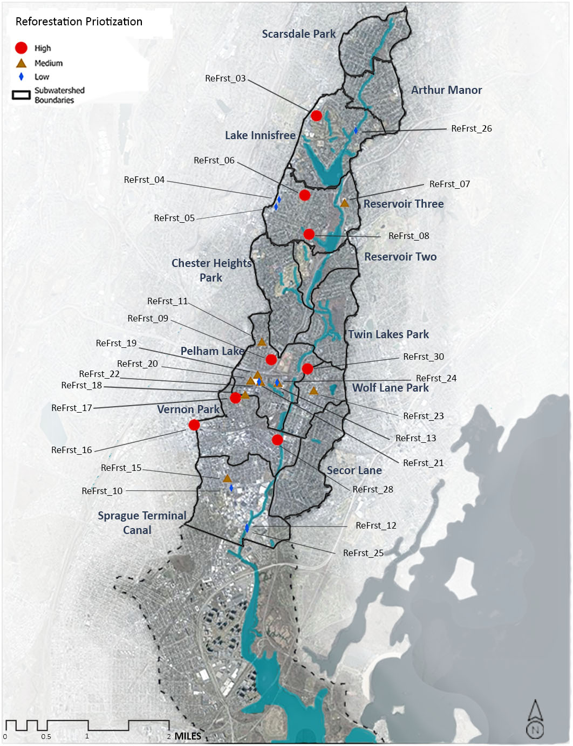
Figure 19. Reforestation Opportunities Based on Prioritization Ranking

Treatment Potential of Improvement Opportunities
Using the Watershed Treatment Model (WTM) developed in Phase 1, Biohabitats conducted a treatment analysis to evaluate the pollutant load reduction potential associated with the suite of proposed restoration opportunities. When compared with the results from Phase 1, the results from this task meet the requirements of Element 2 of the US EPA’s 9E planning process (Expected Load Reductions for Solutions Identified). The methodology for the analysis is described below.

Watershed Treatment Model
For this WTM rerun, “Future Management Practices” were considered to determine the load reduction from proposed restoration opportunities. Retrofit and reforestation opportunities were quantified in this model. The WTM is not set up to account for water quality improvements associated with hotspot opportunities which are largely dependent on outreach and education; however, the WTM rerun does account for recommended street sweeping. These practice types’ efficiencies in removal of pollutants were quantified according to the methodologies as described below.

Land Reclamation/ Reforestation
Reforestation opportunities were classified as land reclamation in the WTM. To calculate the pollutant reduction, the reforestation opportunities’ current land uses and pollutant loading amounts were identified. Then, these spaces were converted to park space. The difference between the current land use and the future “park” land use was calculated to determine the future load reduction. Table 24 provides the acreage of reforestation (accounted for as land reclamation within the WTM) by subwatershed.
Table 24. Acreage of Proposed Reforestation Opportunities by Subwatershed
Subwatershed | Converted Acreage
Lake Innisfree | 0.44
Pelham Lake | 2.17
Reservoir Three | 3.45
Sprague Terminal Canal | 0.70
Vernon Park | 0.84
Wolfs Lane Park | 0.35
No discount rates were applied to land reclamation sites. WTM assumptions include the full implementation of all reforestation opportunities.

Stormwater Retrofits
Drainage areas were delineated for all retrofit opportunities to determine the total area of treatment. The impervious cover within the drainage area was used to determine the Treatable Area.
This analysis utilized New York State Department of Environmental Conservation (NYS DEC) established pollutant removal rates by stormwater facility type. These values determined the new loading rates for the retrofit drainage areas. Table 25 provides the NYS DEC established efficiencies used for the proposed stormwater retrofit opportunities.

Table 25. Pollutant Removal Efficiencies for Proposed Retrofit Opportunity Types
Stormwater Facility Type | Nitrogen (TN) | Phosphorus (TP) | Solids (TSS) | Pathogens (Bacteria)
Pond/Wetland System | 30% | 40% | 80% | 35%
Filtration Bioretention | 30% | 40% | 80% | 70%
Regenerative Stormwater Conveyance | 30% | 40% | 80% | 70%

The WTM allows users to incorporate three Discount Factors for Stormwater Retrofits: Capture Factor (D₁), Design Factor (D₂), and Maintenance Factor (D₃). The factors used in this assessment were as follows:
D₁: The Capture Factor is the fraction of annual rainfall captured by the structure. The NYS DEC uses the 90% rule for water quality volume, so a discount factor of 90% is used assuming that all practices will be sized to meet this rule.
D₂: The Design Factor is based on the adequacy of the existing design standards. No discount was applied since NYS DEC has a design manual that meets all minimum criteria.
D₃: The Maintenance Factor considers the level of maintenance likely to be performed on treatment practices. For the purposes of this effort, a Maintenance Factor of 60% which the WTM defines as a retrofit having “regular maintenance specified in design guidance, but the community has a poor tracking system or limited staff to ensure that maintenance occurs.”
Table 26 provides the acreage of retrofit opportunities identified in each subwatershed.
Table 26. Summary of Retrofit Opportunities
Subwatershed | Bioretention (Acres) | Regenerative Stormwater Conveyance (Acres) | Pond/Wetland System (Acres)
Arthur Manor | 1.17 | - | -
Lake Innisfree | 3.05 | - | -
Pelham Lake | 2.38 | 2.65 | 2.23
Reservoir Three | 2.56 | 3.89 | 8.12
Reservoir Two | - | - | 0.23
Secor Lane | 0.40 | - | -
Sprague Terminal Canal | 4.44 | - | 2.95
Vernon Park | 2.07 | - | -
Wolfs Lane Park | 1.45 | 0.10 | -
Street Sweeping
Recommendations from the hotspot assessment included increased street sweeping for a number of the sites, but in particular for industries located within the Sprague Terminal Canal subwatershed. No discount rates were applied to street sweeping. For the purposes of the WTM re-run, it was assumed that the street sweeping would be conducted to optimize water quality benefits (weekly sweeping using a vacuum assisted street sweeper conducted by trained operators).
Results
The following tables provide the results from the WTM showing the impact of the addition of the restoration opportunities within the watershed. Attachment B shows the results for the WTM re-run.
Table 27. Estimated Load Reductions from Restoration Opportunities
Restoration Opportunity Type | N (lbs/year) | P (lbs/year) | TSS (lbs/year) | Bacteria (billion/year)
Street Sweeping | 0.0083 | 0.0083 | 0.0104 | 0.00
Stormwater Retrofits | 148 | 34 | 18,673 | 4,889,197
Land Reclamation | 26,051 | 4,379 | 1,229,652 | 303,537,265
Total Reduction | 26,199 | 44,413 | 1,248,326 | 308,426,462

Table 28. Comparion of Existing and Estimate Future Loads
WTM Scenario | Load Type | TN | TP | TSS | Bacteria
 |  | lb/year | lb/year | lb/year | billion/year
Existing | Total | 49,255 | 8,126 | 2,277,395 | 797,792,694
 | Storm | 47,042 | 8,025 | 2,252,105 | 797,792,694
 | Non-Storm | 2,213 | 101 | 25,290 | -
With Future Restoration Opportunities | Total | 23,057 | 3,713 | 1,029,070 | 489,366233
 | Storm | 21,560 | 3,655 | 1,010943 | 489,366233
 | Non-Storm | 1,497 | 59 | 18,127 | -

Key Takeaways
The results from the WTM re-run shows a small reduction in pollutant potential from the restoration opportunities, with significantly more impact from land reclamation. In the majority of situations, land reclamation will have a greater impact on pollutant removal because it works to restore the watershed’s natural ecosystem functions such as evapotranspiration and infiltration.

The WTM re-run shows a small impact from the restoration opportunities due to the limited field assessment which identified restoration projects in a subset of the subwatersheds. The sites considered were focused on large, public properties primarily in four specific subwatersheds. There are many more opportunities throughout the Hutchinson River watershed that were not considered, including:
- Private properties or institutional properties with access restrictions for safety and private property permission purposes
- Subwatersheds outside of the scope of the prioritization from Phase I

The sites that were identified in this study can be used as templates that can be applied across similar property types and scenarios throughout the watershed. For example, the application of green streets and the removal of concrete from under utilized parking lots are opportunities that have applicability across the watershed. These opportunities provide practitioners with ideas for larger scale implementation throughout the watershed that will create larger change and improve the ecological condition of the watershed.

Wright, T., C. Swann, K. Cappiella, T. Schueler. 2004. Unified Subwatershed and Site Reconnaissance: A User’s Manual. Manual 11 in the Urban Subwatershed Restoration Manual Series. Center for Watershed Protection. Ellicott City, MD.
Cappiella, K., Schueler, T.R., Tomlinson, J. L., and T. Wright. 2006. Urban Watershed Forestry Manual. Part 3: Urban Tree Planting Guide. Center for Watershed Protection. Ellicott City, MD.
King, D. and P. Hagan. 2011. Cost of Stormwater Management Practices in Maryland Counties. Prepared for Maryland Department of the Environment. University of Maryland Center for Environmental Science. Solomons, MD.
Center for Watershed Protection. 2022. Stormwater Management Design Manual. New York State Department of Environmental Conservation.

